WEEK 5

Name of School: ……………………………………………………………………………….……..
Name of Teacher: ……………………………………………………………………………………
Date: |  | Day: MONDAY |  |  | Strand: VALUES AND BELIEFS
 |  |  |  |  | Sub Strand: OUR BELIEFS
Class: KG 2 |  |  | Class Size:
Content Standard:  K2.3.4.1 Demonstrate understanding of relating well with people with different beliefs. |  |  |  | Indicator:  K2.3.4.1.1 Learners can describe why and how to relate well with everyone regardless of their culture, language or belief.  K2.3.4.1.6 Learners can recognize and describe some simple repeating non numerical patterns (up to a repetition of 3, 1, 2 pattern)
Performance Indicator:  - Learners can describe why and how to relate well with everyone regardless of their culture, language or belief.  - Learners can recognize and describe some simple repeating non numerical patterns (up to a repetition of 3, 1, 2 pattern) |  |  |  |  | Core Competencies:  Communication and collaboration, Critical thinking, Personal Development and Leadership
Keywords: Compose, decompose, materials, concrete
Phase/Duration | Learners’ Activities |  |  |  |  | Resources
PHASE 1: STARTER | Let learners sing a song in relation to the lesson.  RCA QUESTION  1. Did you enjoy the song?  2. What words did you hear in the song?
PHASE 2: NEW LEARNING  CIRCLE TIME | Engage learners in the community circle time.  Sit the children in a circle, facing inwards.  One child is chosen to be “it”. it walks around the circle, gently tapping each other player in turn on the head or shoulder, naming each player as a ‘Duck’. When ready, it chooses one player to be the ‘Goose’ – tapping that player on the head and shout ‘Goose’.  The player selected as Goose stands up and chase It around the circle, trying to tap her before she gets all the way around the circle to sit back in the spot where the Goose was originally sitting.  If the Goose is not able to tag the It, then Goose becomes It and the game continues.
GROUP ACTIVITY 1  (OUTDOOR) | Display a conversational poster and some concrete materials related to the theme and engage learners in active discussion.  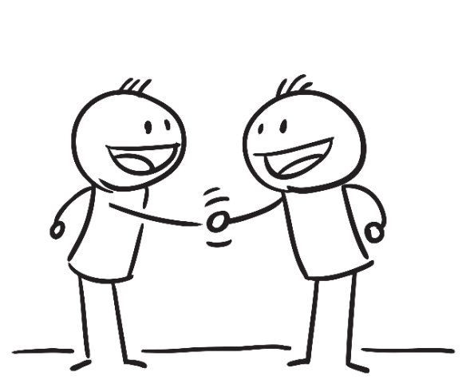  Call on learners randomly to answer questions or contribute to the discussion.  Discuss the different kinds of people we live with and the need to behave appropriately towards all humans.  Sort and group learners according to their tribes or language spoken; let each child pick a friend from a different group and exchange pleasantries.  Let learners count the members in each group and represent it with a model number.  Guide learners to perform simple additions with the numbers identified.  Guide learners to practice the writing of these numbers and then write them in their workbooks.  Teach and sing new action songs in relation to the theme.  Assessment: Learners role play how to relate well with everyone regardless of their culture, language or belief. |  |  |  |  | Big book, word card and sentence card, pictures and videos,
PHONICS | Engage learners to sing songs and recite some familiar rhymes that relates to the target sound.  Guide learners to pronounce and write the target sound in the sand tray or exercise books.  Have learners say three or four words that contain the target sound.  Using flash cards, learners read words that contain the target sound.  RCA QUESTIONS  1. What sound have we learnt today?  2. What other letter sound do you know?  3. Mention any object in the classroom or home that begins with the target letter sound. |  |  |  |  | Word cards, letter cards.
GROUP ACTIVITY 2  (INDOOR) | Show number cards and let learners work in small groups to identify the pattern.  Guide learners to arrange the numeral cards to patterns.  E.g. 11,22, 33, ….  Write a number pattern and let learners copy and write on each row.  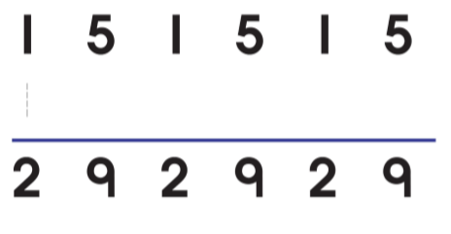  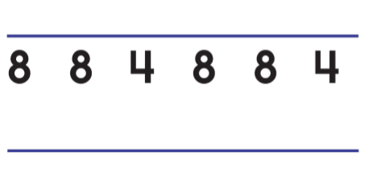  Go around the class and assist those with difficulties.  Group learners to the ‘touch and tell’ game.  Collect several differently textured or shaped items and place them in a paper bag.  Sit opposite your children on the floor.  Call learners in turns, blindfold them or ask him to close his eyes.  Remove an item from the bag and place it in your child’s hands.  Ask him to feel the item carefully and guess what it is.  Provide hints if he has trouble guessing correctly.  The game continues as long as learners are having fun. |  |  |  |  | Big book, word card and sentence card, pictures and videos,
LEARNING CENTER | Engage learners to play freely at the learning centers.  Join in and ask learners questions frequently to guide their play. |  |  |  |  | Learning center
STORY SHARING | Tell learners a story.  Pause regularly and ask questions to make sure learners are following.  RCA QUESTION  1. Was the story interesting?  2. What part of the story did you like?  2. Retell the story to your partner.  4. what have you learnt from the story? |  |  |  |  | Word cards, letter cards.
PHASE 3: REFLECTION | Learners share what they have learnt with their peers.  Give learners homework to do at home

Date: |  | Day: TUESDAY |  |  | Strand: VALUES AND BELIEFS
 |  |  |  |  | Sub Strand: OUR BELIEFS
Class: KG 2 |  |  | Class Size:
Content Standard:  K2.3.4.1 Demonstrate understanding of relating well with people with different beliefs. |  |  |  | Indicator:  K2.3.4.1.2 Use illustrations in a Big book to make predictions and answer simple story map questions about the text.  K2.3.4.1.5 Play different musical instruments and dance to religious songs
Performance Indicator:  - Learners can use illustrations in a Big book to make predictions and answer simple story map questions about the text.  - Learners can play different musical instruments and dance to religious songs |  |  |  |  | Core Competencies:  Communication and collaboration, Critical thinking, Personal Development and Leadership
Phase/Duration | Learners’ Activities |  |  |  |  | Resources
PHASE 1: STARTER | Let learners sing a song in relation to the lesson.`  RCA QUESTION  1. Did you enjoy the song?  2. What words did you hear in the song?
PHASE 2: NEW LEARNING  CIRCLE TIME | Engage learners in the community circle time and play the “Can you guess” game.  Select an interesting and easily visible item located in the room.  Tell your kids you are thinking about something in the room and give them clues such as color, size, or shape.  Have them try to guess the item.  If they guess incorrectly, give them another clue and let them guess again.  Continue as they guess correct.
GROUP ACTIVITY 1  (OUTDOOR) | Take learners through a few pages of a big book (picture walk).  Have learners predict what the story will be, using the pictures in the book.  Read aloud the narrative story related to the theme (Little David and Goliath).  Use the Story Map strategy. Learners answer the story map questions.  E.g. i. What is the setting of the story?  ii. who are the characters?  iii. what is the problem in the story?  iv. what did the character(s) do to solve the problem? v. How was the problem solved?  Focus on what we can learn from the biblical character.  Write level appropriate words in the air, sand, on their arms and in their ruled books and read.  Engage learners to practice with the shapes to be familiar with new words learnt.  Example : the word “shape” looks like this.  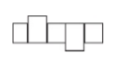  Have your child look at thier vocabulary or spelling word list and draw the word shape around each word.  Learners draw empty word shape for each word.  Cut out each word shape, give learners a fresh copy of thier word list, and see if they can match each word to its shape.  Let learners count the number of sounds in each word and represent them with model numbers.  Learners to arrange the numbers in order on the floor or on the table.  Call learners to take out specified numbers as you mention them.  Assessment: Have learners to tell the story they heard in turns |  |  |  |  | Big book, word card and sentence card, pictures and videos,
PHONICS | Engage learners to sing songs and recite some familiar rhymes that relates to the target sound.  Guide learners to pronounce and write the target sound in the sand tray or exercise books.  Have learners say three or four words that contain the target sound.  Using flash cards, learners read words that contain the target sound.  RCA QUESTIONS  1. What sound have we learnt today?  2. What other letter sound do you know?  3. Mention any object in the classroom or home that begins with the target letter sound. |  |  |  |  | Word cards, letter cards.
GROUP ACTIVITY 2  (INDOOR) | Have different learners show their skills in the Music and dance lesson and by playing musical instruments, drums. Etc.  Learners can use empty tins as instruments and play them.  Some can lead in the songs while others dance.  Play a variety of music using a music box or phone and let learners dance. |  |  |  |  | Big book, word card and sentence card, pictures and videos,
LEARNING CENTER | Engage learners to play freely at the learning centers.  Join in and ask learners questions frequently to guide their play. |  |  |  |  | Learning center
STORY SHARING | Tell learners a story.  Pause regularly and ask questions to make sure learners are following.  RCA QUESTION  1. Was the story interesting?  2. What part of the story did you like?  2. Retell the story to your partner.  4. what have you learnt from the story? |  |  |  |  | Word cards, letter cards.
PHASE 3: REFLECTION | Learners share what they have learnt with their peers.  Give learners homework to do at home

Date: |  | Day: WEDNESDAY |  |  | Strand: VALUES AND BELIEFS
 |  |  |  |  | Sub Strand: OUR BELIEFS
Class: KG 2 |  |  | Class Size:
Content Standard:  K2.3.4.1 Demonstrate understanding of relating well with people with different beliefs. |  |  |  | Indicator:  K2.3.4.1.3 Read level-appropriate sight words from the big book  K2.3.4.1.4. Connect spoken words and sounds to letters in a playful way
Performance Indicator:  - Learners can read level-appropriate sight words from the big book  - Learners connect spoken words and sounds to letters in a playful way |  |  |  |  | Core Competencies:  Communication and collaboration, Critical thinking, Personal Development and Leadership
Keywords: Compose, decompose, materials, concrete
Phase/Duration | Learners’ Activities |  |  |  |  | Resources
PHASE 1: STARTER | Let learners sing a song in relation to the lesson.`  RCA QUESTION  1. Did you enjoy the song?  2. What words did you hear in the song?
PHASE 2: NEW LEARNING  CIRCLE TIME | Engage learners in the community circle time.  Read a book about cars and trucks together and study the pictures.  Cut the top and bottom off a large box, leaving the sides intact.  Guide learners to decorate the outside of the box to look like a car or truck using felt pens, stickers, etc.  When the car is finished, let your kids take a drive around the classroom.  For added fun, set up roads by laying down rope as a guide, and set up stop signs along the route.  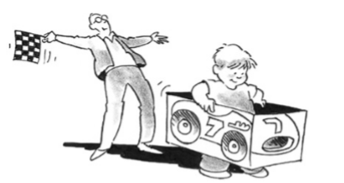 |  |  |  |  | large box, felt pens, stickers
GROUP ACTIVITY 1  (OUTDOOR) | Display sight words on word cards and guide learners to read  Have them look for the sight words from the big book and guide learners to use the words to form short and simple sentences.  Copy words in the exercise book.  Write level appropriate content vocabulary in their ruled exercised books and read them to each other.  Have learners to read the sight words on the chart in turns.  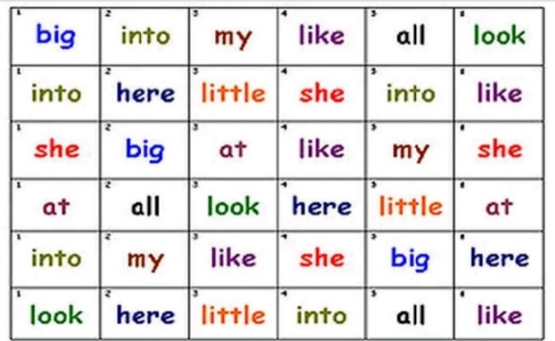  Engage learners to play the “Label the school” game.  Walk around each room of the school with your child. As she names the school items, use a permanent marker to write the names on index cards or sentence strips. Attach them to the item with tape.  Each time kids sits on, opens, sleeps in, or uses one of the items, draw their attention to the card and ask them to read it.  To make the game a little more interesting, you can even ask them to use the word in a sentence, such as, “This is madam’s chair and I am not supposed to sit in it,” or “ I like to write on the blackboard”. |  |  |  |  | Big book, word card and sentence card, pictures and videos,
PHONICS | Engage learners to sing songs and recite some familiar rhymes that relates to the target sound.  Guide learners to pronounce and write the target sound in the sand tray or exercise books.  Have learners say three or four words that contain the target sound.  Using flash cards, learners read words that contain the target sound.  RCA QUESTIONS  1. What sound have we learnt today?  2. What other letter sound do you know?  3. Mention any object in the classroom or home that begins with the target letter sound. |  |  |  |  | Word cards, letter cards.
GROUP ACTIVITY 2  (INDOOR) | Practice letter ladder-game. Draw a grid on the floor of the classroom or outside.  Write letters the learners have learnt so far in the grid on the floor which looks like this. a k f D s b m O p h k H  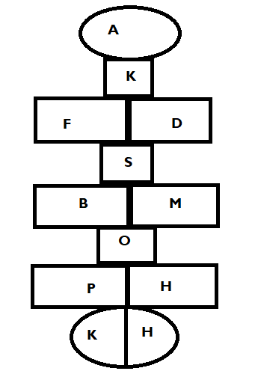  Divide the class into 2, 3, 4 groups (this depends on the number of learners in the class).  Read the sounds and call on the group to send a volunteer to jump/hop on the letter in the box on the floor.  If the child is correct, the group gets a point.  If the child is incorrect, the group loses their turn/ chance and does not get a point.  It moves to another group.  If nobody knows it, the teacher needs to demonstrate and hop on the grid and no one get a point.  Select a group to start with.  Let learners count the number of letter sounds in the grid.  Assessment: Learners stand at the start line.  Teacher calls out 'if you have a /t/ in your name step forward' or 'if your name begins with /f/ step forward'. The person to get to the finish line wins. |  |  |  |  | Big book, word card and sentence card, pictures and videos,
LEARNING CENTER | Engage learners to play freely at the literacy center.  Letter puzzle – children complete the letter puzzles by matching the capital letters to the lowercase letters  Join in and ask learners questions frequently to guide their play. |  |  |  |  | Learning center
STORY SHARING | Tell learners a story.  Pause regularly and ask questions to make sure learners are following.  RCA QUESTION  1. Was the story interesting?  2. What part of the story did you like?  2. Retell the story to your partner.  4. what have you learnt from the story? |  |  |  |  | Word cards, letter cards.
PHASE 3: REFLECTION | Learners share what they have learnt with their peers.  Give learners homework to do at home

Date: |  | Day: THURSDAY |  |  | Strand: VALUES AND BELIEFS
 |  |  |  |  | Sub Strand: OUR BELIEFS
Class: KG 2 |  |  | Class Size:
Content Standard:  K2.3.4.1 Demonstrate understanding of relating well with people with different beliefs. |  |  |  | Indicator:  K2.3.4.1.3 Read level-appropriate sight words from the big book  K2.3.4.1.4. Connect spoken words and sounds to letters in a playful way.
Performance Indicator:  - Learners can connect spoken words and sounds to letters in a playful way.  - Learners can read level-appropriate sight words from the big book |  |  |  |  | Core Competencies:  Communication and collaboration, Critical thinking, Personal Development and Leadership
Keywords: Compose, decompose, materials, concrete
Phase/Duration | Learners’ Activities |  |  |  |  | Resources
PHASE 1: STARTER | Let learners sing a song in relation to the lesson.`  RCA QUESTION  1. Did you enjoy the song?  2. What words did you hear in the song?
PHASE 2: NEW LEARNING  CIRCLE TIME | Engage learners in the community circle time.  BACK WORDS.  Put learners into groups to play the backward game.  Start with simple sentences like “More milk please” and “Thank you.”  Say them backwards: “Please milk more” and“ You thank.”  Demonstrate a few times so she understands how to play.  Progress to longer sentences as your kids get better at playing the game. |  |  |  |  | flashcards
GROUP ACTIVITY 1  (OUTDOOR) | Practice letter ladder-game Draw a grid on the floor of the classroom or outside.  Write letters the learners have learnt so far in the grid on the floor which looks like this. a k f D s b m O p h k H  Divide the class into 2, 3, 4 groups (this depends on the number of learners in the class).  Read the sounds and call on the group to send a volunteer to jump/hop on the letter in the box on the floor.  If the child is correct, the group gets a point.  If the child is incorrect, the group loses their turn/ chance and does not get a point.  It moves to another group.  If nobody knows it, the teacher needs to demonstrate and hop on the grid and no one get a point.  Select a group to start with.  Let learners count the number of letter sounds in the grid.  Assessment: Learners stand at the start line.  Teacher calls out 'if you have a /t/ in your name step forward' or 'if your name begins with /f/ step forward'. The person to get to the finish line wins. |  |  |  |  | Big book, word card and sentence card, pictures and videos,
PHONICS | Engage learners to sing songs and recite some familiar rhymes that relates to the target sound.  Guide learners to pronounce and write the target sound in the sand tray or exercise books.  Have learners say three or four words that contain the target sound.  Using flash cards, learners read words that contain the target sound.  RCA QUESTIONS  1. What sound have we learnt today?  2. What other letter sound do you know?  3. Mention any object in the classroom or home that begins with the target letter sound. |  |  |  |  | Word cards, letter cards.
GROUP ACTIVITY 2  (INDOOR) | Display sight words on word cards and guide learners to read  Have them look for the sight words from the big book and guide learners to use the words to form short and simple sentences.  Copy words in the exercise book.  Write level appropriate content vocabulary in their ruled exercised books and read them to each other.  Have learners to read the sight words on the chart in turns.  Engage learners to play the “Label the school” game.  Walk around each room of the school with your child. As she names the school items, use a permanent marker to write the names on index cards or sentence strips. Attach them to the item with tape.  Each time kids sits on, opens, sleeps in, or uses one of the items, draw their attention to the card and ask them to read it.  To make the game a little more interesting, you can even ask them to use the word in a sentence, such as, “This is madam’s chair and I am not supposed to sit in it,” or “ I like to write on the blackboard”. |  |  |  |  | Big book, word card and sentence card, pictures and videos,
LEARNING CENTER | Engage learners to play freely at the learning centers.  Join in and ask learners questions frequently to guide their play. |  |  |  |  | Learning center
STORY SHARING | Tell learners a story.  Pause regularly and ask questions to make sure learners are following.  RCA QUESTION  1. Was the story interesting?  2. What part of the story did you like?  2. Retell the story to your partner.  4. what have you learnt from the story? |  |  |  |  | Word cards, letter cards.
PHASE 3: REFLECTION | Learners share what they have learnt with their peers.  Give learners homework to do at home

Date: |  | Day: FRIDAY |  |  | Strand: VALUES AND BELIEFS
 |  |  |  |  | Sub Strand: OUR BELIEFS
Class: KG 2 |  |  | Class Size:
CONTENT STANDARD:  K2.3.4.1 Demonstrate understanding of relating well with people with different beliefs. |  |  |  | Indicator:  K2.3.4.1.5 Play different musical instruments and dance to religious songs  K2.3.4.1.6 Recognize and describe some simple repeating non numerical patterns (up to a repetition of 3, 1, 2 pattern)
Performance Indicator:  - Learners can recognize and describe some simple repeating non numerical patterns (up to a repetition of 3, 1, 2 pattern).  - Learners can play different musical instruments and dance to religious songs |  |  |  |  | Core Competencies:  Communication and collaboration, Critical thinking, Personal Development and Leadership
Keywords: Compose, decompose, materials, concrete
Phase/Duration | Learners’ Activities |  |  |  |  | Resources
PHASE 1: STARTER | Let learners sing a song in relation to the lesson.`  RCA QUESTION  1. Did you enjoy the song?  2. What words did you hear in the song?
PHASE 2: NEW LEARNING  CIRCLE TIME | Engage learners in the community circle time.  ANIMAL WALK  Your child will have fun walking just like the animals!  Help him use his imagination to move his arms, legs, head, and body.  Leaf through various picture books about animals.  As you read, encourage your kids to walk like the animals in the books.  Help them by describing and demonstrating if necessary. For instance, show them how the duck waddles, the crab moves sideways, the kangaroo leaps, the elephant lumbers, the worm inches, etc. |  |  |  |  | picture books
GROUP ACTIVITY 1  (OUTDOOR) | Have different learners show their skills in the Music and dance lesson and by playing musical instruments, drums. Etc.  Learners can use empty tins as instruments and play them.  Some can lead in the songs while others dance.  Play a variety of music using a music box or phone and let learners dance.  Show number cards and let learners work in small groups to identify the pattern.  Guide learners to arrange the numeral cards to patterns. E.g. 11,22, 33, ….  Teach rhymes and songs as learners sing along  Have learners dance with actions as they sing the songs  Make a choice to use any of the learning centers created  Assessment: Learners in groups perform to the whole class by playing different musical instruments and dance to songs |  |  |  |  | Big book, word card and sentence card, pictures and videos,
PHONICS | Engage learners to sing songs and recite some familiar rhymes that relates to the target sound.  Guide learners to pronounce and write the target sound in the sand tray or exercise books.  Have learners say three or four words that contain the target sound.  Using flash cards, learners read words that contain the target sound.  RCA QUESTIONS  1. What sound have we learnt today?  2. What other letter sound do you know?  3. Mention any object in the classroom or home that begins with the target letter sound. |  |  |  |  | Word cards, letter cards.
GROUP ACTIVITY 2  (INDOOR) | Engage learners to play the ‘four corners’ game.  Assign each corner of the class with numbers or popular characters in a story.  Share numbers to learners and let everyone stand in their respective corner.  Stand in the middle of the class with a giant dice.  The teacher rolls the dice, and the number that shows up is the corner to be out.  If he rolled a five, all will sing and dance to a familiar rhyme.  If he rolled a six, everyone out will get back to their respective corners.  The last corner to remain standing in its corner wins!  Lead kids to play the musical chairs game.  Place chairs in a line or in a circle facing out.  Lead children (more than the number of chairs available) around the chairs while singing a song.  At the end of the song, each child must sit down in the chair by which he or she is standing.  The child who remains standing is out of the game.  The last person to remain siting is the winner.  Repeat the game as long as the children are having fun.  Engage learners to play the hot potato game.  Players arrange themselves in a circle and toss a small, round object (a tennis ball, an orange, or even a real potato will suffice) to each other while music plays.  The player who is holding the “hot potato” when the music stops is out.  The game continues until one player is left — that player is the winner. |  |  |  |  | Big book, word card and sentence card, pictures and videos,
LEARNING CENTER | Engage learners to play freely at the learning centers.  Join in and ask learners questions frequently to guide their play. |  |  |  |  | Learning center
STORY SHARING | Tell learners a story.  Pause regularly and ask questions to make sure learners are following.  RCA QUESTION  1. Was the story interesting?  2. What part of the story did you like?  2. Retell the story to your partner.  4. what have you learnt from the story? |  |  |  |  | Word cards, letter cards.
PHASE 3: REFLECTION | Learners share what they have learnt with their peers.  Give learners homework to do at home

